Project 18-2: Maintain products
For this project, you’ll create a form that lets the user maintain products.
The design of the Product Maintenance form
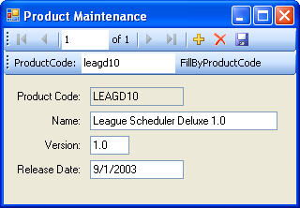
Operation
- When this application first starts, the data in the first row of the Products table is displayed. Then the user can display the data for other rows using the navigation buttons in the first toolbar.
- To display the data for a row with a specific product code, the user enters the product code in the second toolbar and then clicks the FillByProductCode button.
- To modify an existing row, the user enters the modifications and then clicks the Save Data button in the first toolbar.
- To delete an existing row, the user clicks the Delete button in the first toolbar, followed by the Save Data button.
- To add a new row, the user clicks the Add New button in the first toolbar, enters the data for the new row, and then clicks the Save Data button.
Specifications
- This application should handle SQL Server and ADO.NET exceptions.
- Limit the number of characters that can be entered into the Name text box so that the name doesn’t exceed the size allowed by the Name column.
- Modify the code that’s generated for the parameterized query to make it easier to read.
- You will need to let the user enter a product code for a new row, but you should not let the user change an existing product code. To accomplish that, you’ll need to change the properties of this text box when the user clicks the Add New button and when the user clicks the Delete or Save Data button when a new row is being added.
- Move the focus to the appropriate text box depending on whether an existing row is displayed or a new row is being added.
Notes
- This project requires the use of a data source with a single table, data-bound text boxes, a parameterized query, and error handling.
- Optional: Add validating events for the four text boxes on the form. However, this will cause difficulties with the code that provides for entering a product code for a new row. In that case, you may want to allow existing product codes to be changed to avoid these difficulties.
- Alternative: You can simplify this project by allowing existing product codes to be changed. If you do that, you may want to code a method that removes leading and trailing spaces from the product code since this column has a fixed size of 10 characters.
- Extra: If you have read chapter 19, you can enhance the second toolbar so it provides for retrieving all the rows from the Products table after a specific row is retrieved.

